Course ___Methods_Test 4_ Year __12_______

Student name: ________________ Teacher name: ________________

Date: Weds 26 August

Task type: Response

Time allowed for this task: _____45______ mins

Number of questions: _____6______

Materials required: Calculator with CAS capability (to be provided by the student)

Standard items: Pens (blue/black preferred), pencils (including coloured), sharpener, correction fluid/tape, eraser, ruler, highlighters

Special items: Drawing instruments, templates, notes on one unfolded sheet of
A4 paper, and up to three calculators approved for use in the WACE examinations

Marks available: __46____ marks

Task weighting: __10__%

Formula sheet provided: Yes

Note: All part questions worth more than 2 marks require working to obtain full marks.
Q1 (1, 1, 1 & 3 = 6 marks)
Consider a continuous random variable X that is uniformly distributed as follows.

Determine the following:
Solution
Specific behaviours
determines area

Solution
Same result as (a)

Specific behaviours
same result as (a)

Solution
1

Specific behaviours
states prob

Solution
Specific behaviours
uses conditional formula/idea
correct denominator
correct prob

Q2 (3 marks)
Consider a continuous random variable X shown below.
Solve for the constant exactly. (Show all working)

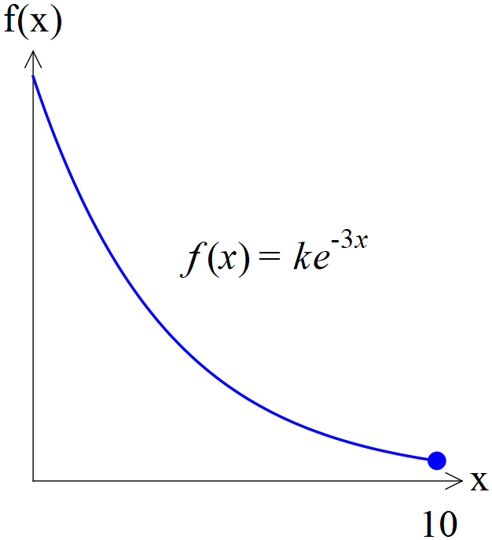
Solution
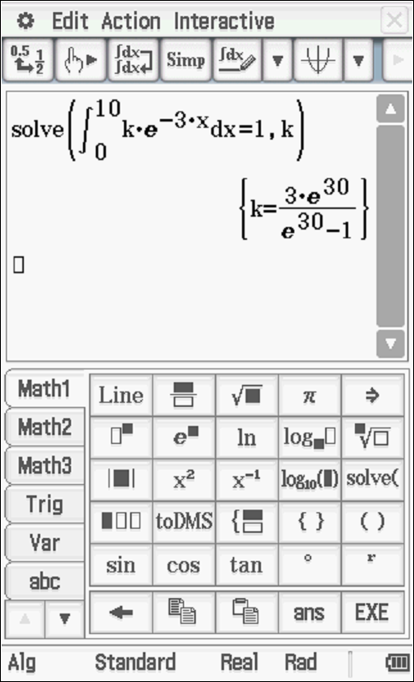

Specific behaviours
uses integral with correct limits
solves backwards from a total area of one
states exact value of k
Q3 (1, 4, 1 & 2 = 8 marks)
Consider a continuous random variable X shown below. (Not drawn to scale)
- Determine the value of the constant .

Solution
Specific behaviours
states value

- Determine

Solution

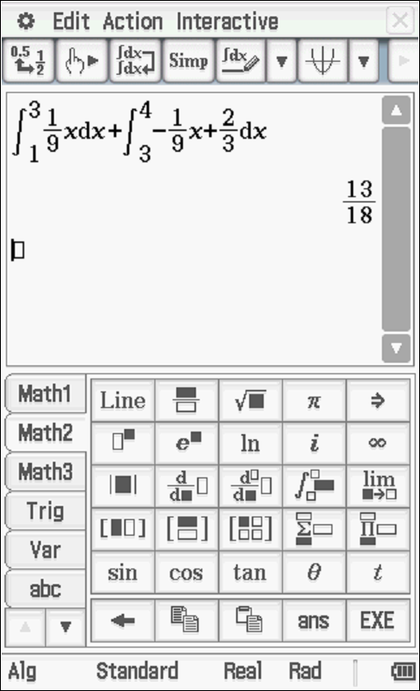
Specific behaviours
determines equation of one slope or uses similar triangles
determines equation of second slope or uses similar triangles
uses integration or trapeziums to find areas
states final value

- Determine
Solution
3 by inspection and the symmetry around x=3

Specific behaviours
states value

- Determine Standard deviation of
Solution
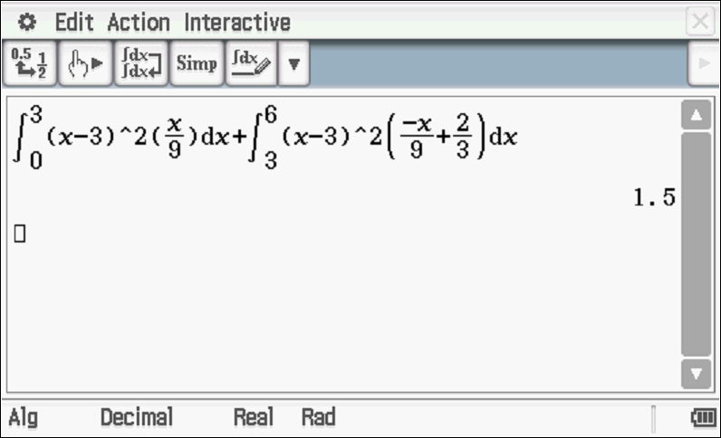
Specific behaviours
states correct integral for 0 to 3
states correct integral for 3 to 6 and approx. answer for stdev
(full marks for answer only)

Q4 (2, 2 ,2 & 1 = 7 marks)
A continuous random variable, has a pdf
Determine:

Solution
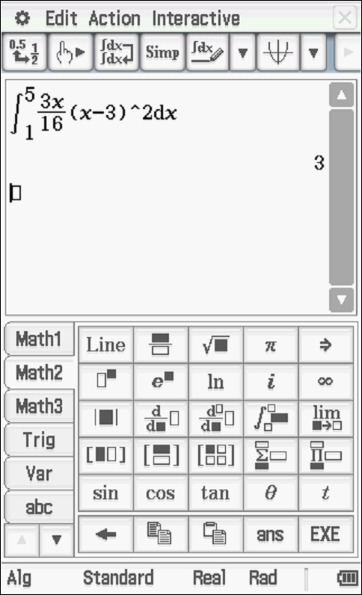

Specific behaviours
uses correct integral
states mean

Solution
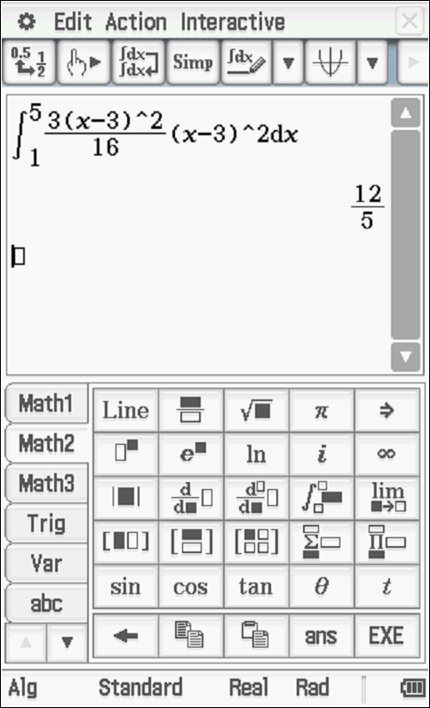

Specific behaviours
uses correct integral
states Variance

- Standard deviation

Solution
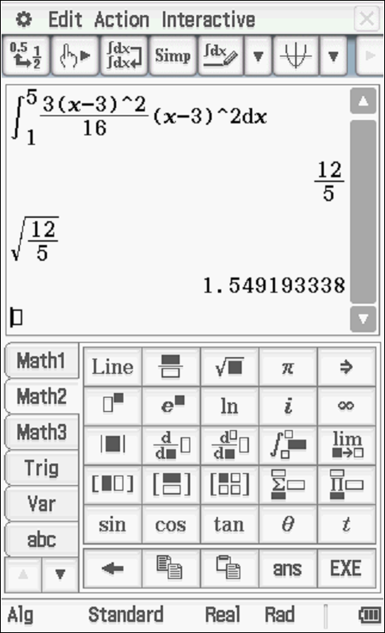

Specific behaviours
uses square root
states standard dev

Solution
Specific behaviours
multiplies by 9

Q5 (2, 2, 2 & 3 =9 marks)
The results for a class test, can be modelled by a Normal Distribution given by .
Determine:
- The 78th percentile.
Solution
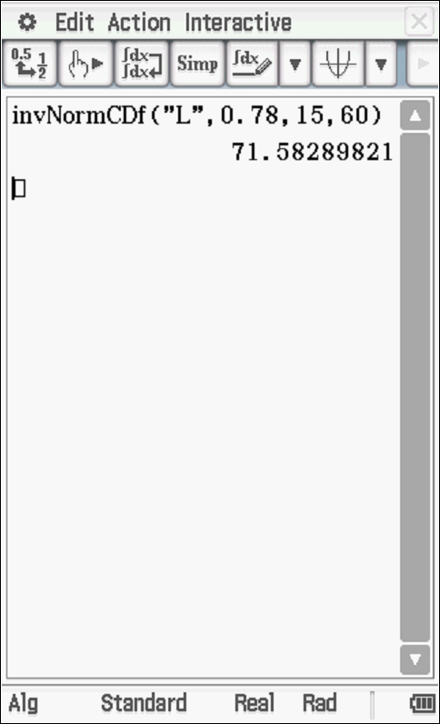

Specific behaviours
uses inverse prob
states percentile

Solution
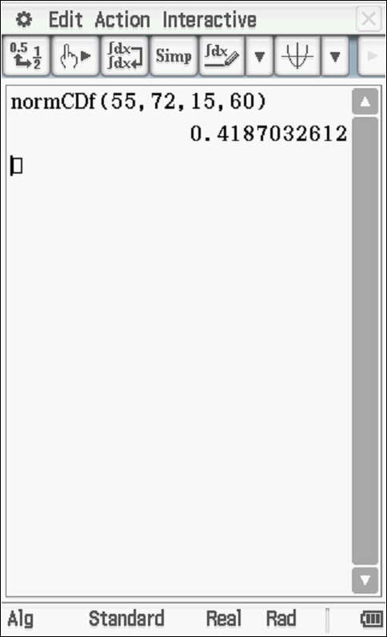

Specific behaviours
uses correct parameters
states prob

- The cut-off for an A grade given that this grade is only given to the top 20%.

Solution
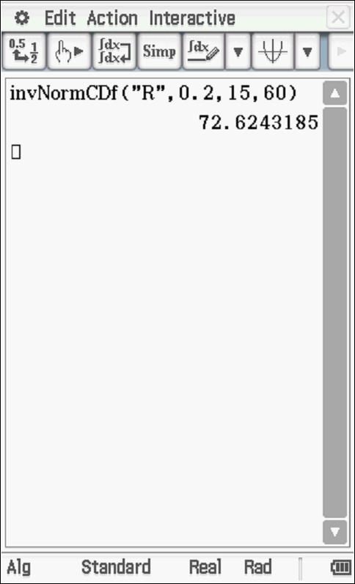

Specific behaviours
uses right tail
states cut off

- A second test is a Normal Distribution with a mean of 55. Given that the 58th percentile is 62, determine the standard deviation.

Solution
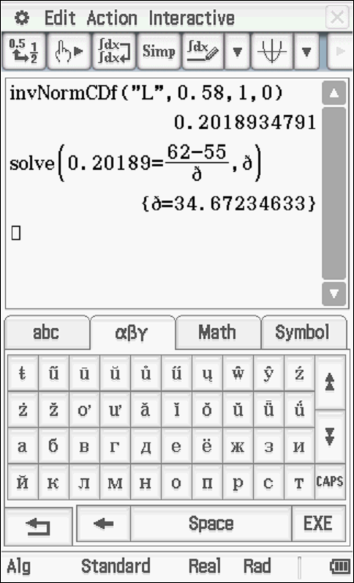

Specific behaviours
solves for z score
uses rule that links x and z scores
solves for standard dev

Q6 (3, 3, 3, 2 & 2 =13 marks)
The time it takes to be served at a supermarket checkout, seconds, can be modelled by a normal distribution as follows seconds. The assistant at the check out is paid according to the following scheme.

- Fill in the probability line of the above table rounded to three decimal places.
Solution
Time served
In seconds
Payment $P | $5 | $7 | $12 | $15 | $18
Probability  To 4 decimal places | 0.0114  Or  0.0117 | 0.0642 | 0.8655 | 0.0580 | 0.0006  Or  0.0009

Specific behaviours
contains two correct probs
contains five correct probs
all probs rounded to 3 or 4 dp

- Determine the expected payment showing full working.

Solution
Specific behaviours
shows sum of products
uses 5 products
determines mean (accept different values of probs) (2 marks for answer only)

- Determine the variance of the payment showing full working.

Solution
Specific behaviours
uses mean from b in calc
uses correct sum of terms
determines variance (2 marks for answer only)

- If the payments were all increased by 30% and a bonus of $2 added to each category, determine the new mean and standard deviation.

Solution
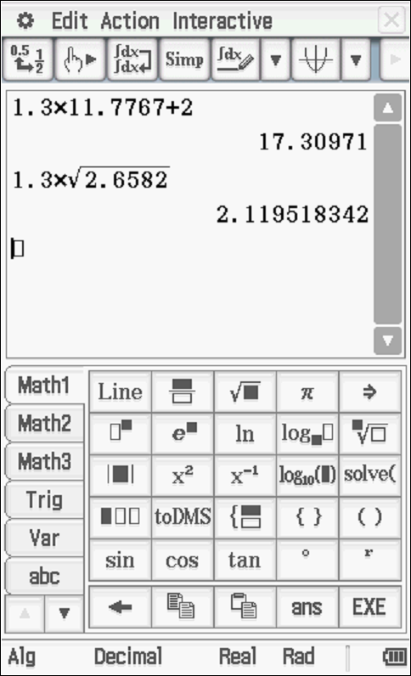

Specific behaviours
determines new mean
determines new standard deviation

- Explain a limitation of the Normal distribution model and show a calculation to support this.
Solution
Model allows negative times

Specific behaviours
mentions negative times
states a positive prob that time is less than zero

